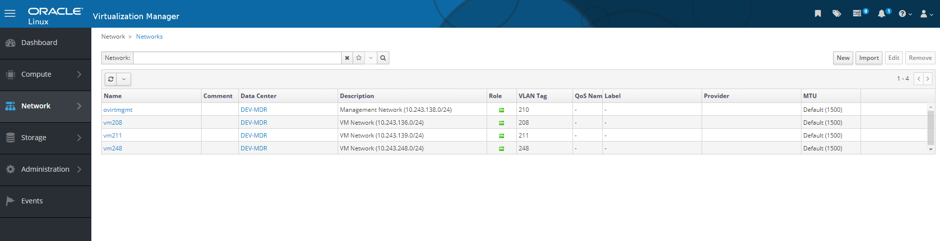

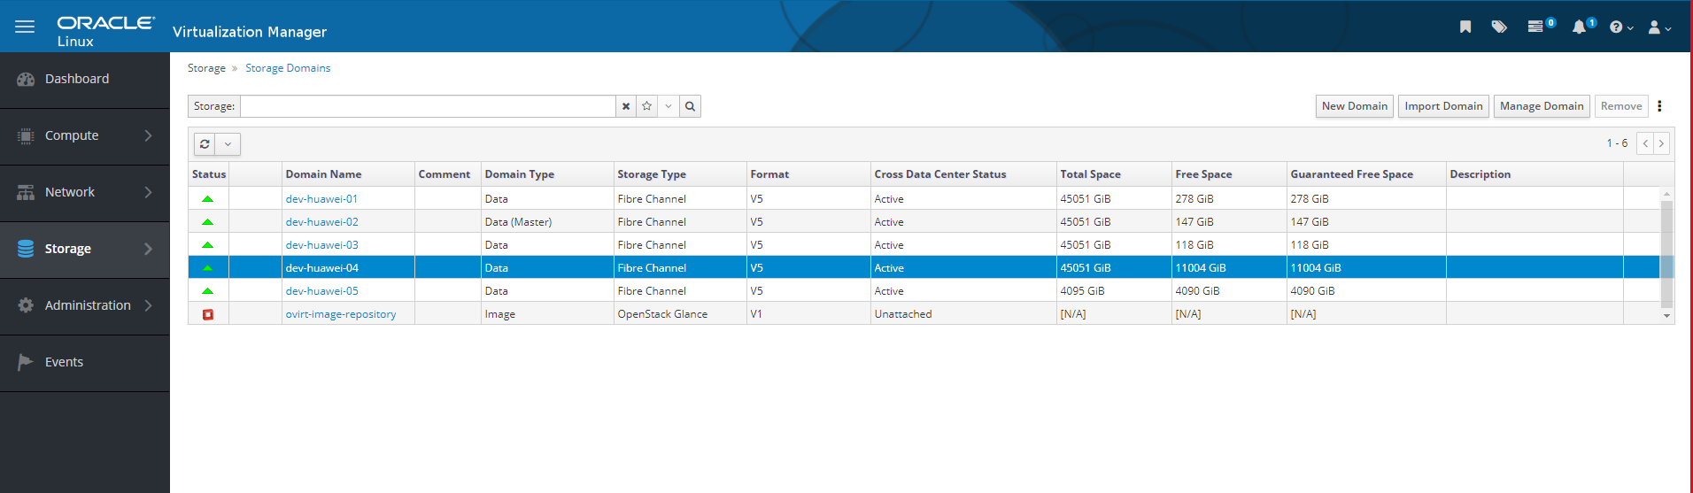

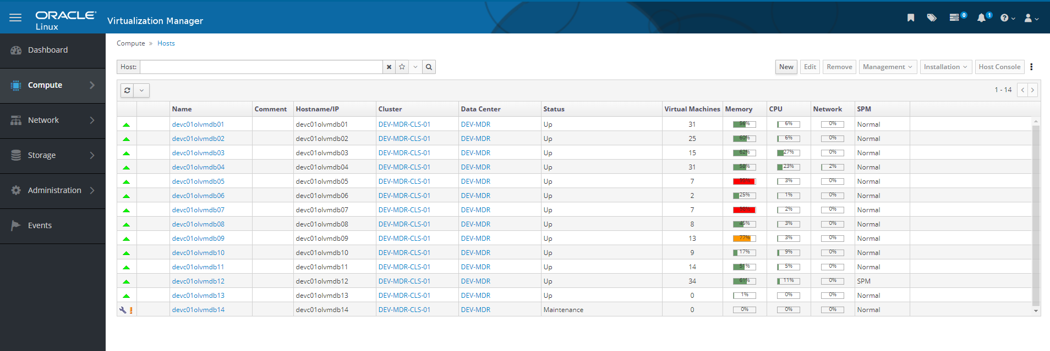

3 configuration

1. single instance with file system

2. single instance with asm

3. rac (cluster) with asm

netconfig.ini

params.ini

deploycluster --createdisk TEST_DATA1,storagedomain=dev-huawei-04,size=100G,shared=false,thin=false

deploycluster -C OL85-DB1914-04 -M TEST --cloneattach TEST_DATA1 --clonenet nic1=vm248 --clonemem 16G --clonecpu 8,1,1 --clonetype full --clonedeploy -N utils/netconfig-single-asm.ini -P utils/params-single-asm.ini